**CIOBrain Deployment**

Project Plan

Anton Horvath

Anuja Sahu

Scott Lorance

Kevin Lieng

Jose Colina Salas

Saige Wright

# Abstract

# This document contains the goals, methods, and description of the CIOBrain deployment project. It outlines the proposed schedule for project completion, the team’s planned methods, the deliverables, and other relevant information on how the project will be finished. It aims to establish the standards the team will hold ourselves to, as well as the expectations of the stakeholders.

# 

# Table of Contents

Abstract 2

Table of Contents 3

List of Figures 4

List of Tables 5

Introduction 6

Stakeholders 6

Lifecycle Model 7

Risk Analysis 7

Hardware and Software Requirements 7

Deliverables 8

Schedule 8

Monitoring and Reporting 10

Professional Standards 11

# List of Figures

| 1.1 List Schedules | 9 |
| --- | --- |
| 1.2 Timeline schedule | 9 |
| 1.3 Completion Installation | 10 |

# List of Tables

| Table 1.1 - Risk Table | 9 |
| --- | --- |
| Table 1.2 - Schedule of Document Deliverables | 7 |

# Introduction

The CIOBrain application is a two-part solution hosted on Azure for documenting and visualizing relationships between enterprise assets to support analysis of the company’s IT infrastructure by the CIO in the event of data breaches. It sets out to help CIOs make decisions for adding new assets or capabilities.

# Stakeholders

The CIOBrain application has stakeholders that can be divided into two camps, both of which have aligned objectives.

The first group of stakeholders would be the end Users. As the title of the application would imply, the project is intended for company Chief Information Officers (CIO). The role of the CIO is to manage IT systems and personnel, as well as direct the development of new IT solutions for a company. The aim of CIOBrain for these stakeholders is to better organize information in a convenient manner, as was accomplished by the last team. This project's continuation headed by our team aims to make installing this system and deploying it easier for the CIO, to save time and make the solution we are providing more appealing.

It is likely that the CIO is not the only one involved in using the system, managers operating under the CIO are likely to be involved in setting up and providing the information that fills the information web that the product provides.

The second camp of stakeholders is the project sponsors, who are creating this project as a marketable product, rather than a solution for in house needs. As the product is being designed to be sold, convenience is a priority as it makes the product more appealing, but there is the additional concern for propriety- the product sponsors do not seek to have the project be open source, and would like to prevent easy reverse engineering.

# Lifecycle Model

The lifecycle model used for this project will be an Agile type model. This is because the personnel in this group are adapted well to this model and due to the short timeframe that the project needs to be done within the 4 months this was objectively the best option compared to iterative or waterfall methods since we need to pump this out in such a short amount of time. We’re utilizing a scrum type Agile model in which we have sprints of developments to follow. In our project management software we have set up Gantt chart-like schedules to follow these sprints.

# Risk Analysis

| Risk Type | Probability | Impact |
| --- | --- | --- |
| Documentation Confusion From Previous Project Work | High | Tolerable |
| Team Scheduling Conflicts | Moderate | Moderate |
| Specification Miscommunication | Low | Serious |
| Change/Enhancement Request Configuration Conflicts | Moderate | Tolerable |
| Inconsistencies Throughout Additions | Low | Tolerable |

### Table 1.1 - Risk Chart

# Hardware and Software Requirements

**R1**. CIOBrain must be able to be run on Microsoft Azure

**R2.** CIOBrain can be run on a personal computer

**R3**. CIOBrain will have its database taken from an Excel spreadsheet.

**R4.** CIOBrain will be running on Windows systems primarily.

**R5.** CIOBrain can be compatible with MacOS

**R6.** CIOBrain will have a one click installation msi file

**R7.** CIOBrain will have a one click transfer capability from desktop app to Microsoft Azure

**R8.** CIOBrain will have production-ready features to be able to operate in Microsoft Azure

**R9.** The Azure system will be able to handle multiple users running on CIOBrain at once

**R10.** CIOBrain will support login functionality utilizing a password system.

**R11.** The msi installation file will be a one touch installation

# Deliverables

**D.0** Install and run CIO application on local Windows machine and on Azure, testing current functionality.

**D.1** Build easy one-click installation file with run desktop icon called ciobrainTrialv3.msi.

* CIO’s should be able to launch the application by simply running through an installation process, which will add the CIOBrain application icon to the desktop. They will then be able to launch the application by simply clicking on the icon.



### Figure 1.1 - Desktop Icon

**D.2** Build easy one-click data transfer capability from local CIOBrain app to Azure-hosted app.

* CIO’s will be able to click on a **Sync** button that will save data to a CIOBrain project in the Azure-hosted web app version. They will then be able to view their project online through any device.

**D.3** Build authentication (login/password access) for Azure-hosted app

* CIO’s should be able to log in or sign up for a CIOBrain account. When they click the **Sync** button in the local application, it will ask them to log in to their CIOBrain account before transferring the project data to their account data
* Possible auto-sync capabilities while the user is editing within the local app (Internet available)?

# Schedule

| Assignment | Members | Due Date |
| --- | --- | --- |
| Project Management Plan | All members | September 9 |
| Requirements Documentation | All members | September 23 |
| Architecture Documentation | All members | October 7 |
| Detailed Design Documentation | All members | October 21 |
| Testing Plan | All members | November 11 |
| Final Project Report | All members | December 2 |
| Final Project Demonstration | All members | December 2 |

### Table 1.2 - Schedule of Document Deliverables

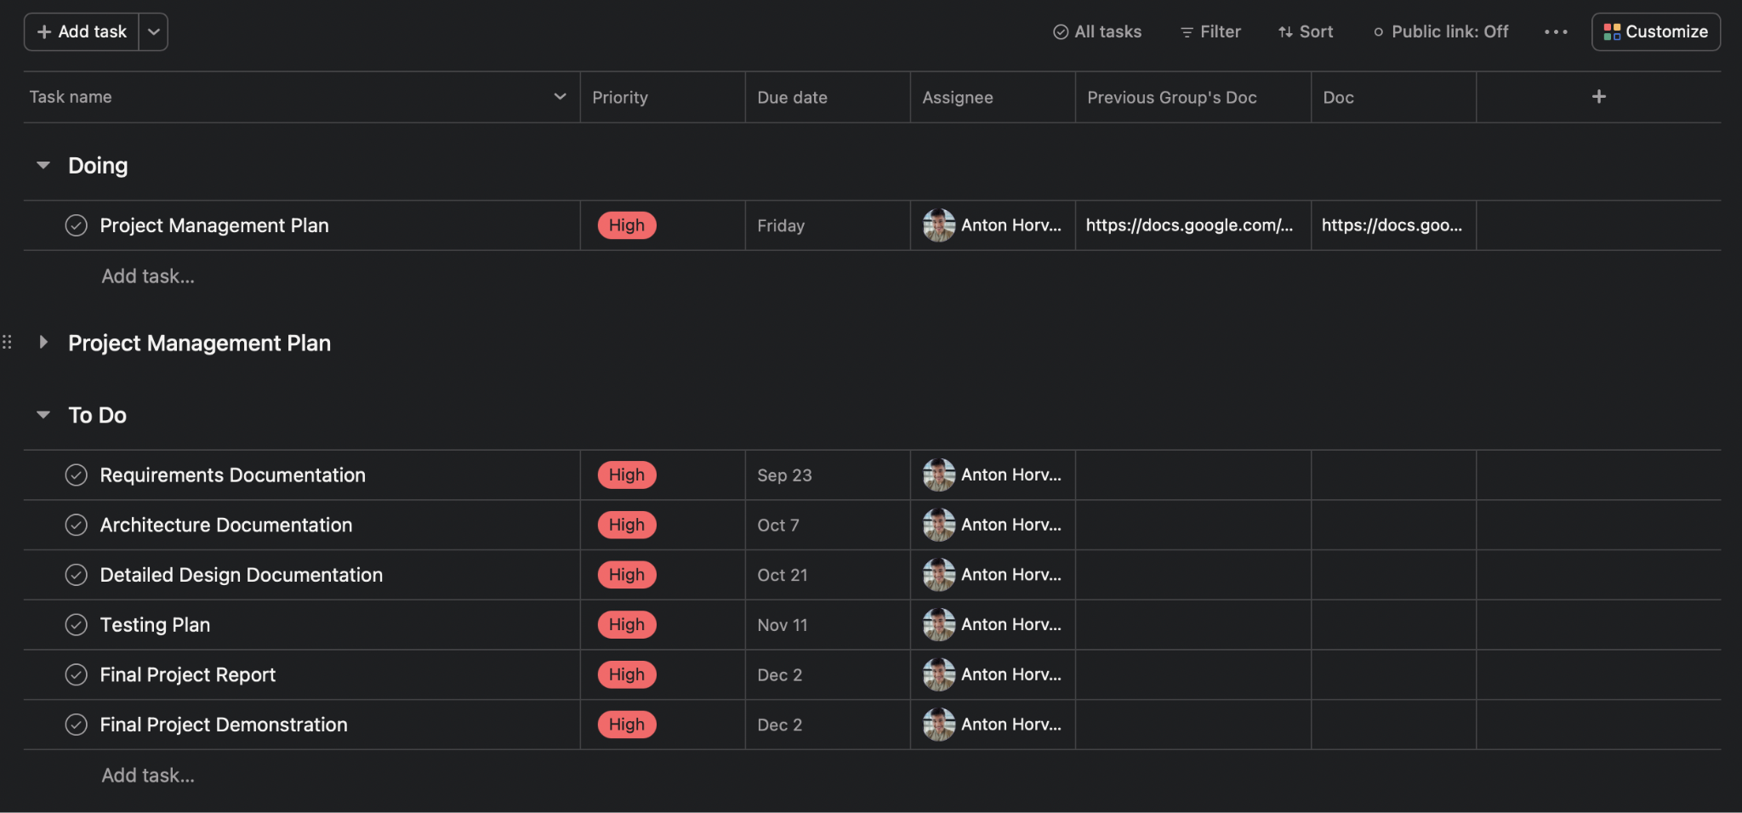

### Figure 1.2 - List Schedule

### Figure 1.3 - Timeline Schedule

# Monitoring and Reporting

Our team has weekly sprints beginning on Monday and ending on Friday. Sprint progress will be communicated to the sponsor along with the next sprint’s tasks at the end of each week on Friday at 2:00pm CT over Microsoft Teams. Project management, including tracking assignments and tasks for all team members, will be conducted using [Asana](https://asana.com/?noredirect). The team will also report and communicate through a private Discord group chat that has been created.

Progress on documentation deliverables will be apparent at all stages of construction as Google Docs will be used for collaboration. If for any reason a section assigned to a team member on Asana is not being completed, the assignee will be contacted on Discord privately to work things out. Completion of tasks by team members can be indicated on Asana.

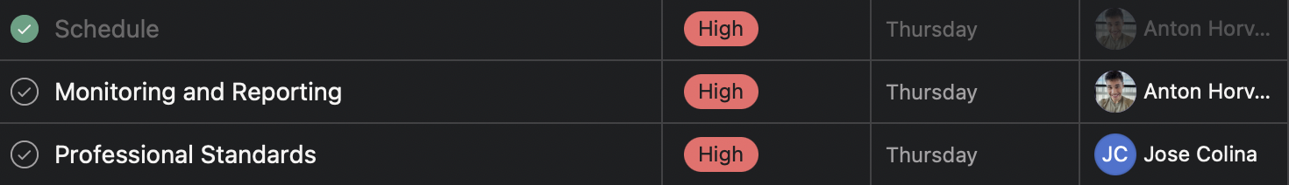

### Figure 1.4 - Completion Indication

Progress on software development/coding will be tracked using GitHub. Repositories will be created as needed with review requirements for any pull requests added so at least one member will need to look over code being added.

# Professional Standards

* The team meets every Friday at 1:00pm to discuss project issues and progression. Each member is expected to attend and participate during the meeting
* The team meets with Tom Hill every Friday at 2:00pm to present project progression, and ask questions
* Team members must complete work assigned every Thursday at 12:00pm
* Team members shall maintain independence and integrity in their judgment
* Team members shall be fair to and supportive with each other
* Team members are expected to communicate any problems encountered
* Team members shall be respectful with each other at all times
* Team members shall ensure the product meets the highest quality standard possible